**An Improved Covid-19 Chest X-Ray Image Predictions using Hybridized HOG and LBP Feature Excretion for CNN classification**

**Abstract**

*In consequences of any work health crisis, medical sectors will promptly and constantly be researching on new approach or technology to control, contain, diagnose, and detect the early spread of the deadly disease infection. The most challenging world health outbreak is that of the Coronavirus infection (covid-19) which is cause by severe acute respiratory syndrome coronaviruses 2 (SARS-CoV-2) virus strain. Various machine learning model has been proposed to detect and diagnose early infection of the virus, in other to attain proper precaution against the covid-19 virus. however, according Jumani and other researcher’s, parameter optimization can be adopter to attain better accuracy on the chest X-ray image of covid-19 and other related disease. Hence, this research work adopts a hybridized cascaded feature extraction technique (LBP-HOG) and CNN for the deep learning classification model. The merging of LBP and HOG feature extraction significantly improve the performance level of the deep learning CNN classifier. In consequence, a result of 95% accuracy, 92% precision and 93% recall are attained by the proposed model.*

1. **Introduction**

Considering the high rate increase in Covid-19 cases been discovery every day is of high alarming, this is due to the lack of accurate detection mechanism. A great number of people in different country has been affected and killed as a result of fast spread of the deadly disease. It is identify in the research work of Chen [2] that the deadly virus can be easily spread fast and quickly via the airway medium. Hence, this result to inflammation by causing an obstacle or blockage for the intake of oxygen. The identification or diagnoses of this virus has present a big challenge of unresolved issues to the medical practitioners across the globe. Based on the change in climatically condition around the word, many other deadly diseases as emanate as a result of Covid-19 virus. According to the virus word statistic almost all the country around the globe is affected with the Covid-19. The highest number of confirmed recorded cases of Covid-19 case is recorded in India [2]. According to research coronavirus belong to a set of similar RNA viruses, which as prove illness in mammals and birds. The emergent of the Covid-19 virus was first identify in Wuhan China on December 31st 2019. According to the findings of Rahman et al [3] over 34.8 million of infected people as been identified has at October 4th 2020, and more than A million of people has been dead has a result of the deadly virus.

Intelligent behaviors that are demonstrated by machine are call Artificial intelligent or AI. Terms such as Artificial Intelligent (AI), Deep Learning (DL), Data Science (DS), and machine learning (ML) are all corelated words. The capability of a machine to mimic the behavior, learn and think logically without human intervention is also term AI [4] .

Furthermore, the technology that mathematically represent how human brain function or behave is term Artificial Neuron Network (ANN). The ANN is capable of learning or extracting important feature from a dataset on its own. In comparison with the traditional approach, deep learning has proven too be better in area such as text processing, speech recognition, image processing and recognition [5]. Artificial Neuron network with multiple hidden layer is called deep learning, and its known as and an automatic machine learning approach which uses the architecture of neural network. The Recurrent Neural Network (RNN), Convolution Neural Network (CNN), Deep Neural Network (DNN), and Feed Forward Neural Network (FFN) are various type of artificial neural network been developed to solve varieties of issues. The FNN is considered as the basic unit of an artificial neural network architecture family, in feed forward data are only feed from one layer to another layer via the hidden layer [6]. While the recurrent neural network is specifically design to solve sequential problem, such as text preprocessing, voice recognitions and video processing [7]. Computational problems such as image detection, segmentation and recognitions are mostly solve using Convolutional Neural Network. The layers in the CNN architecture are made up of convolutional layer (Performing auto feature extraction), Pooling Layer (Used in dimensionality reduction), and finally the dense layer (containing fully connected neurons) [6].

However, the feature selection process involve task use in filtering out or selecting best attribute or variable that best describe and image or data without lost in quality of images. The better understanding of a data or images can be done using feature extraction techniques. Moreover, it improve of machine prediction, accuracy level, training time and minimize cost of computation [8]. Many feature extractions have been developed in image processing, recognitions, segmentation and classification. Typical example of feature descriptors

Histogram of Oriented Gradient (HOG) and Local Binary Pattern (LBP). The HOG techniques his developed in 2005, and it’s a feature descriptor used in the field of image processing (mainly object detection), the techniques takes the local neighborhood of an image and count the incidences in the edge direction [9]. The Local Binary Pattern (LBP) is considered as an efficient operator for texture which is used in labeling the pixels of images by thresholding pixels at the neighborhood and the result is considered as a binary pixels [10].

1. **Research problem**

It has been identify in literature that existing design model on detecting Covid-19 cases are affected with non-substantial amount of chest X-Ray image, undeployable model to cutting edge device, issues of data overfitting, high memory requirement and finally the computational cost of the models [11]. However, it’s essential to improve on the classification accuracy of the chest X-Ray images of the Covid-19 cases and other disease capable of affecting the lungs, by adopting parameter optimizer [12]. It’s now identify in the research work of Jumani et al [1] that LBP feature extraction alone cannot extract all important features, future work was now suggested to by the researchers to adopt the combination of Local Binary Pattern (LBP) and Histogram of Oriented Gradient (HOG) for extracting important features in an images. In consequence, this lead to the adoption of HOG and LBP in this for extracting important image features in Covid-19 Radiography Chest X-Ray images.

1. **Aim and objective**

The primary aim of the research paper is to adopt Histogram of Oriented Gradient and Local Binary Pattern feature extraction techniques in Covid-19 Radiography Chest X-Ray image classification using CNN. In achieving the aim following objectives below has to be accomplished.

1. Defining issues related to existing Chest X-Ray models for Covid-19.
2. Collection or Gathering of Radiography Covid-19 Chest X-ray Scan image dataset.
3. Feature Extraction using HOG and LBP.
4. Developed the CNN Model using the feature extracted.
5. Evaluated the developed model using standard metrics (accuracy, precision, recall and F1 score).
6. **Literature Review**

Rehman et al [13] proposed in is work a real-time computer aided diagnosis (CAD) method to support physicians and prevent further spreading of the disease. A convolutional neural network (CNN) -based Residual neural network (Resnet50) was adopted for detecting covid-19 through CXR images and achieved 98% accuracy. The CAD system uses advanced load balancer and resilience features to achieve fault tolerance with zero delays and perceives more infected cases during this pandemic. This work used limited number of X-ray images for the diagnosis

Base on the research paper of Jumani et al [1] which is titled ‘*facial expression recognition with histogram of oriented gradients using CNN’* . in the paper a modern method is introduce to tackle the classification and recognition of facial expression by considering the FER2013 database which consist of 7 different facial expression class (fear, surprise, angry, sad, neutral, sad, disgust, happy). Considering the past few decades the challenge of facial recognition still remains due to the high variation between class. The researcher adopts two model, this includes; FER using convolutional neural network (FER-CNN) and the Histogram of oriented gradients with convolutional neural networks (FER-HOGCNN). According to the gotten the FER-CNN model was able to give an accuracy of 98%, 72% and the FER-HOGCNN has an accuracy of 97% and 70%. Hence, this shows that the FER-CNN perform better that that of the FER-HOGCNN. in conclusion the research helps in the improvement of FER System for image processing, and the research suggest a future work by hybridizing HOG and LBP for feature extraction before feeding it into the neural network.

It is identify by Ri et al [14] that the deadly coronavirus which also refers to as COVID-19 has infected 20million and above people in a very short period of time, which is now announced to be a global pandemic. Ri also stated in this work title:” improved *classification coronavirus disease (covid-19) based on the combination of texture feature using CT scan and X-ray images*” that its essential to carry out an initial screening in other to control the rapid spread of the deadly disease. The X-Ray images and the Computed Tomography (CT) are both important data for diagnosing the lung condition of a patient having COVID-19 symptoms. However, it’s important to have a machine learning approach that can early detect the a COVID-19 condition using the CT scan and X-Ray images. The researcher proposed a model that is based on machine learning for COVID-19 classification using textual feature techniques. In the research paper three tactual feature approach is adopted, this include; Gray level co-occurrence matrix (GLCM), Local Binary Pattern (LBP), and the Histogram of Oriented Gradient (HOG) which are used in performing feature extractions. This feature extraction approach is adopted to increase the accuracy and efficient improve computation. The support vector machine (SVM) algorithm is considered for image classification. Training was performed on 1100 CT scan image and 1100 X-ray Images. Accuracy of 97% on CT image and 99% accuracy on X-ray images.

Hira et al [15] ] introduced a deep learning-based approach that can differentiate COVID- 19 disease patients from viral pneumonia, bacterial pneumonia, and healthy (normal) cases. This work used nine convolutional neural network-based architecture (AlexNet, GoogleNet, ResNet-50, Se-ResNet-50, DenseNet121, Inception V4, Inception ResNet V2, ResNeXt-50, and Se-ResNeXt-50). Experimental results indicate that the pre-trained model Se-ResNeXt-50 achieves the highest classification accuracy of 99.32% for binary class and 97.55% for multi-class among all pre-trained models.

Oh et al [16] proposed a patch-based convolutional neural network approach with a relatively small number of trainable parameters to address the difficulty involved in the collection of large CXR data set for deep neural network training. The method uses statistical analysis of the potential imaging biomarkers of the CXR radiographs. The method achieved state-of-the-art performance and provides clinically interpretable saliency maps, which are useful for covid-19 diagnosis and patient triage.

1. **Research Methodology**

The section contains the technical information about the scientific approach adopted in the research work. This includes source of data collection, data exploration, image preprocessing, feature extraction techniques, system modelling and evaluation. In Additions, the system architecture explaining the entire proposed LBP-HOB-CNN model, and finally the system requirement.

1. **Data Collection**

In this research work the Covid-19 Radiography image dataset is download from the Kaggle online data science repository. Kaggle is considered one of the largest data science machine learning community, it enable data science researcher to carry out research work, recruiting, identification and solving of scientific problems [17]. The downloaded dataset includes; covid-19, Normal, and Pneumonia Chest X-ray scan sample images placed in separate folders along with their mask image. Covid-19 consist of 3916 image samples, 10192 Normal X-ray scan images and 1342 Pneumonia data image samples. This make a total of 15153 total sample images for training and testing. Samples of images from each class with be showcase using the figures below.

**Figure 1. Covid-19 Chest X-ray samples**

|  |  |
| --- | --- |
|  |  |
|  |  |
|  |  |

The figure 1 above is used to sample 6 images out of the 3916 covid-19 image datasets available, the images are in PNG format with image and dimension of (299,299,3).

**Figure 2. Normal Chest X-ray samples**

|  |  |
| --- | --- |
|  |  |
|  |  |
|  |  |

Based on figure 2. The images of Normal Chest X-Ray Scan are depicted with 6 examples form the total 10192 available image samples. All the image in this group are of PNG format with (299,299,3) in size and dimension.

**Figure 3. Pneumonia Chest X-ray samples**

|  |  |
| --- | --- |
|  |  |
|  |  |
|  |  |

Image of Pneumonia cases are also showcase using the figure 3 above. The image in this group also consist of PNG image format, with size and dimension of (299,299,3).

1. **The Covid-19 Radiography Chest X-ray Dataset**

Team of researchers from the university of Qatar, Doha and Dhaka do the hard work of collating and organizing the Radiography Chest X-Ray Scan images. Other teams from Malaysia and Pakistan also collaborate with medical doctors to create samples of chest x-rays. The three major classes or group of cases considered in the paper includes.

1. Covid-19 positives sample cases
2. Normal Image sample cases
3. 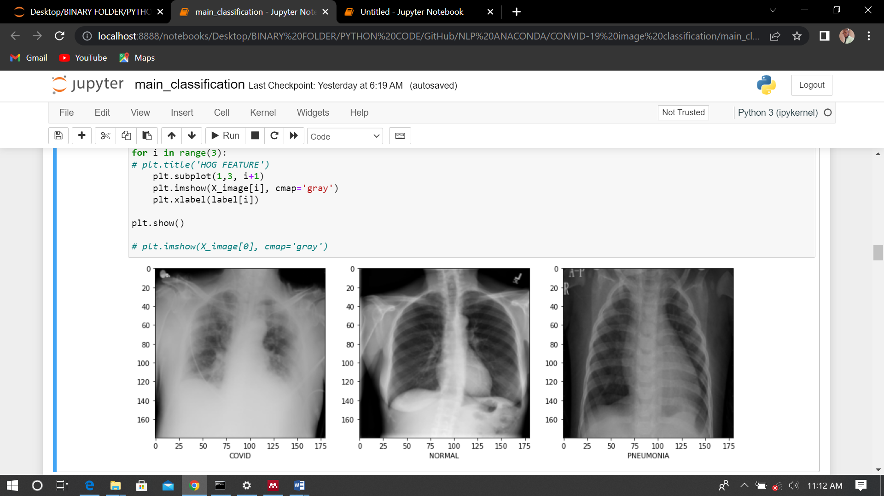Pneumonia Image sample cases.

However, the covid-19 radiography chest x-ray scan consist of 3616 covid-19 case image samples, 10192 Normal case image samples and 1342 Pneumonia case image samples. Hence, 15153 total images are available for developing the propose model (LBP-HOG-CNN). The figure below displays the amount of image samples available for each class.

**Figure 4. Radiography X-Ray image dataset count.**

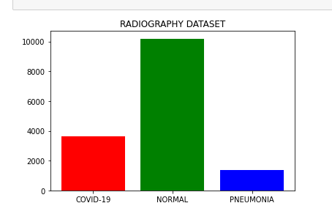

In respect to the figure 4 above it can be clearly seen that the Normal case has the largest amount of data around 10,000 sample, while the Pneumonia with the smallest set of images, consisting of about 2,000 image samples. While the covid-19 count is in between other class with an image count of approximately 4,000 samples. The figure 5 below shows a sample from each class (covid-19, normal and pneumonia)

**Figure 5. Sample from each class.**

1. **Features Extraction**

this section introduces the techniques or method adopted in this research paper to extract important feature from the Radiography image dataset. After Preprocessing operation (scaling of image, and normalization) are been carry out on an image, the next process is to perform feature extraction. The process by which important attribute that best describe an image are extracted from the original raw image, for the purpose of easy processing and enhancement of machine learning understanding, the process termed feature extraction. The stage is essential where the dimensionality, complexity or quality of the image is needed to be reduced, without losing relevant information of the image for faster processing. This stage of eliminate redundancy. Considering this work, two approaches will be used or considered in extracting important features from the covid-19 radiography chest image dataset. The techniques include the Local Binary Pattern (LBP) and Histogram of Oriented Gradient (HOG).

1. **Local Binary Pattern**

the local binary pattern popularly known as LBP, is a feature extraction technique popularly used in image processing. The LBP frequent usage is based on is simplicity and low computational cost, real time processing of application and efficient feature extractions. The LBP techniques or method defines the area of each pixel of a particular image and then assign a label to these pixels using binary numbers. The articulation of LBP can be represented in a decimal form given a pixel at location (Xc, Yc) using the below equation [18].

*LBPP, R* (XC, YC) = ….Eq (1)[19]

Considering eq 1. the ic ­and ip  specify the gray level value in the middle pixel of the image and P in the above equation denoting the neighboring pixels within the circle neighborhood with the radius of R. moreover, the function of S(x) is denoted using the below mathematical equation[19].

S(x)= …. Eq (2)[19]

The LBP method is applied to the entire 15153 images. The figure below shows the raw image input using PyPlot library in python. an instance of image from each class are display below. and figure 7 depicting image sample after performing LBP feature extraction operation on the raw images.

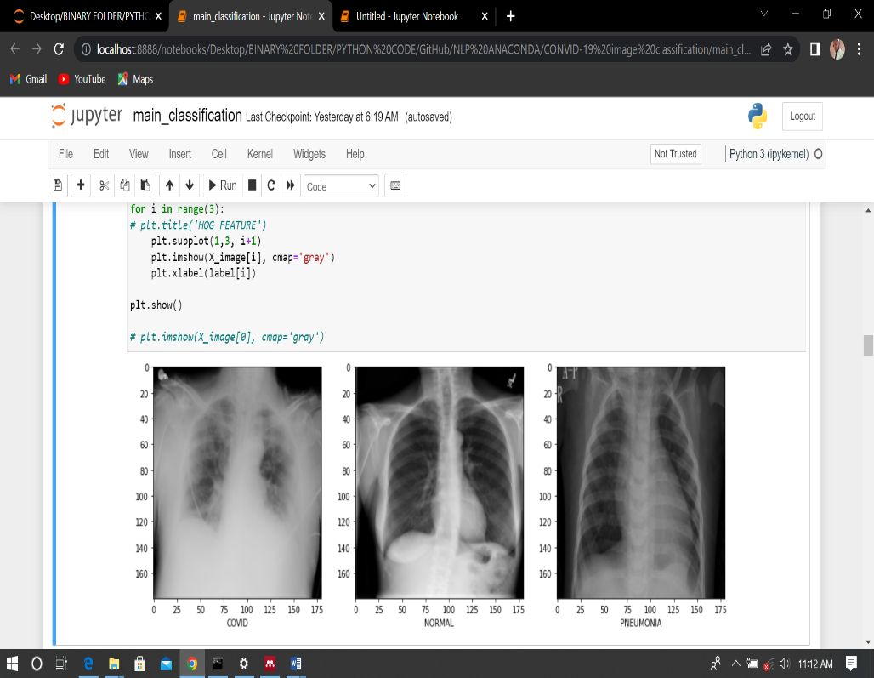**Fig 6 The raw image before LBP**

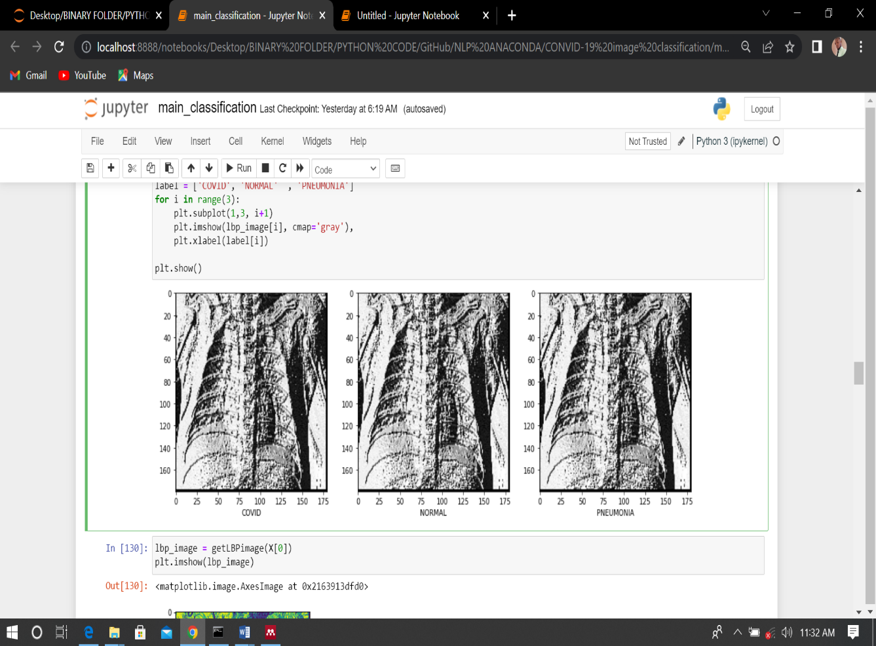**Fig 7 LBP feature extracted image.**

1. **Histogram of Oriented Gradient**

Another popularly used feature extraction techniques in the field of image processing and computer vision is Histogram of Oriented Gradient (HOG). This research work considered using this technique in because HOG techniques helps in performing complex task such as image detection and recognition. It also help in elimination of data redundant and reduce computation cost [3]. HOG is used in this work to extraction important features form covid-19 Radiography images, that can help in improving the image classification. The Gradient, thus the direction of X and Y are important for representing a complex shape (corners and edges). The directions of the a given gradient denote the direction in change of pixel intensity of the image. For instance, given and image of *f*(x,y) the gradient of that image can be mathematically expressed as [3].

∆*f*==………. Eq (3)

Based on the mathematical expression above, the is known as the derivative of the image in respect to ‘x’ and is the derivative of the image in respect to ‘y’. then the derivative can be further calculated based on the Eq4 below.

*f*x(x)*=*=*f*(x+1)-*f*(x-1) …….… Eq (4)

*f*y(y)*=*=*f*(y+1)-*f*(y-1) …….…. Eq (5)[3]

practically, the computed derivative is calculated by convoluting the images in conjunction with x- and y-axes using the kernels [-1 0 1] and . after the gradient has been computed the direction and magnitude of the calculated gradients can now be computed using the below formulas [3].

g= ……….…. Eq (6)[3]

θ=tan-1 ………….…. Eq (7)[3]

Furthermore, after second feature extraction from the LBP image using HOG, the resulted images from each class (covid-19, Normal, and Pneumonia) is sample below.

**Fig 8 HOG feature extracted image**

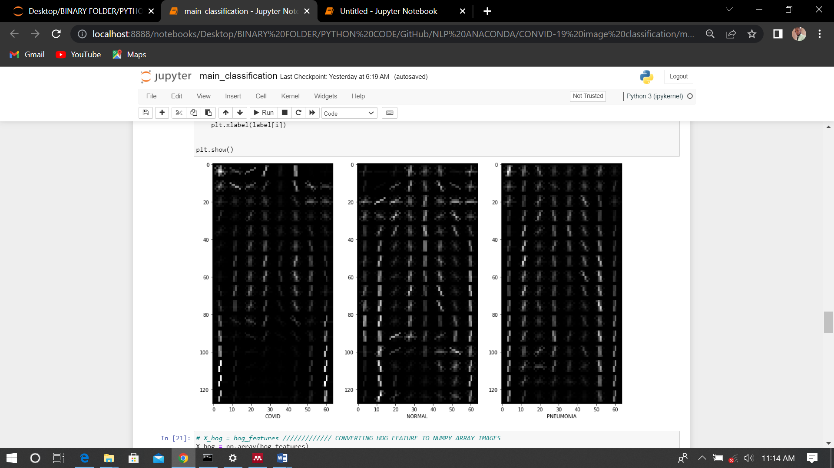

1. **Convolution Neural Network**

Convolutional Neural Network (CNN) belongs to the family of deep neural network, which widely adopted in the field of computer vision and processing of image. The CNN is capable of extracting features automatically from an image. Convolutional neural network mimics the pattern of biological neuron process where individual neural are fully connected to each other. The word convolution in CNN means transformation operation within the domain of image processing, this process filters out small section of the main image and they are passed to calculate the average weighted value, the filter matrix is called Kernel. The mathematical representation of 2D coevolution space is shown in the equation below [3].

y=……………………………………. Eq (8)

considering the equation 8 the ‘x’ and ‘k’ are considered as the inputted image and the convolution kernel. The ‘y’ denote the convolution operation that exist in between the result in the output image. The (m, n) and (i , j) index specifies the width and the height of the kernel and the inputted image. Generally, Convolution network perform scaling on the inputted image and various type of padding operation are considered to facilitate the convolution operation on the entire image. Another import parameter of a convolution is the stride, which denote the number of pixel the kernel covers or moves after every convolution operation. However, in deep learning images are reshape to equal height and width. Hence, kernel is designed to have equal width and height [2].

1. **Proposed Model Data Flow**

**Fig 9. HOG-LBP-CNN based convid-19 classification data flow model**

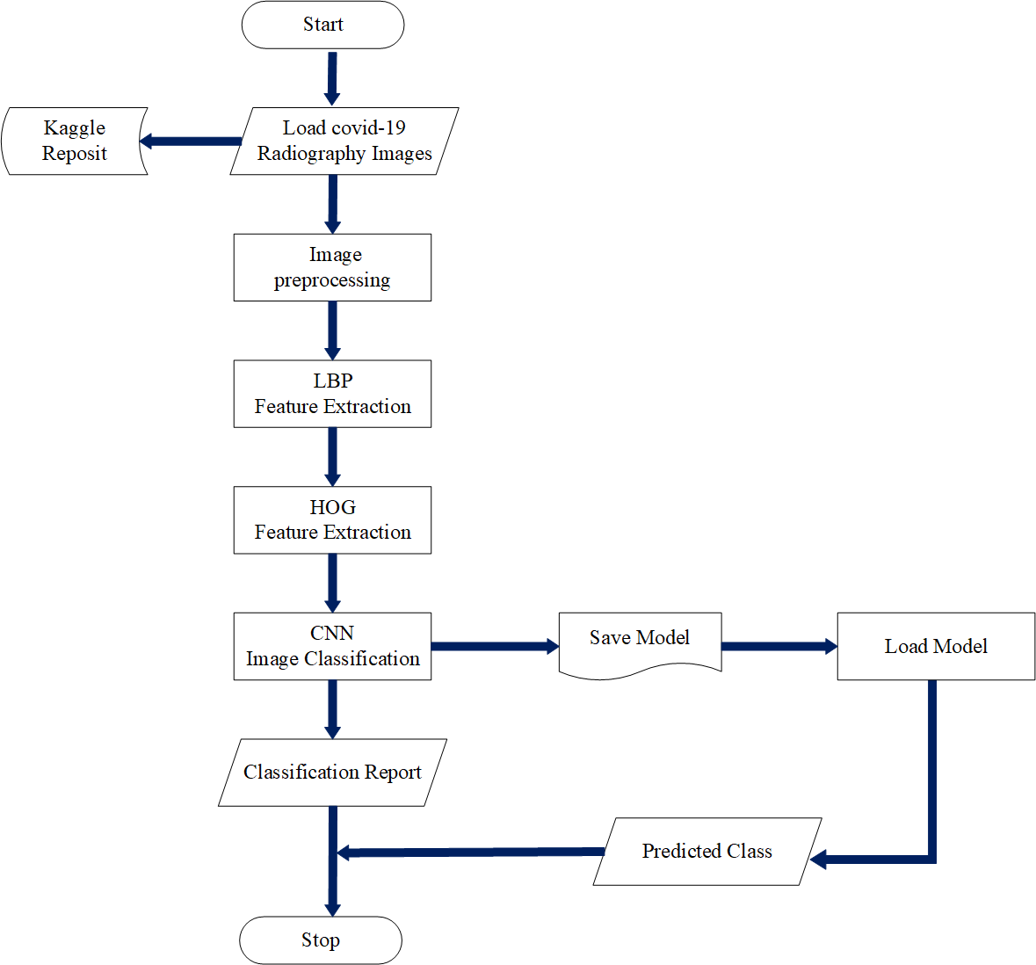

the figure 9. Indicate the dataflow of the proposed LBP-HOB-CNN Covid-19 X-ray classification model. The initial point to the terminating point are indicated in the figure using various symbol, oval shape indicate beginning and ending of the program, trapezium shape indication input operation, the rectangle denotes execution and the arrow shows the direction of the program. Covid-19 Radiograph Scan image dataset is loaded directly or from your local storage as input. Image are being inputted into the preprocessing stage, this stage encompasses rescaling of image, reduction of image dimension, conversion of images into gray scale image, and standardization of images. The next step is to forward the preprocessed images into the first layer of feature extraction using the Local Binary Pattern (LBP) feature extraction techniques and next extraction layer uses the Histogram of Oriented Gradient (HOG). furthermore, after the feature extraction process, the image dataset is forwarded to the Convolutional Neural Network (CNN) deep learning algorithm. The CNN perform what is call Convolution, the process of automatic feature extraction and either Max or Average Pooling in other to reduce image dimensionality. Fully processed images can now be forwarded to the deep neural network for classification. The model classification report is collected, viewed or save for prediction and deployment purpose. Then finally the program terminated.

1. **Proposed (LBP-HOG-CNN Model)**

Based on figure 9 The Proposed Local Binary Pattern and Histogram of Oriented Gradient for extraction of feature and classification using convolution neural network, is depicted using the architecture diagram below. In respect to the diagram below raw images of all 15,153 with dimension of 299 by 299, are feed into the Local Binary Descriptor (LBP) for feature extraction with the image shape and dimension of (180 by 180, 3). The output feature extracted of images using LBP are further engineered using the Histogram of Oriented Gradient (HOG) and it required the image to be first reduced into 128 by 64-dimension images. Furthermore, the output image from the HOG feature descriptor are now feed into the coevolution layer along with is max pooling layer for further dimensionality reduction.

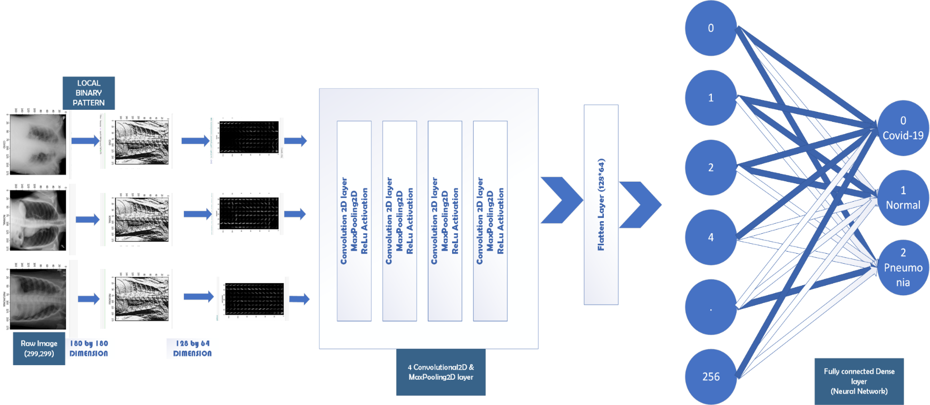

**Fig 10 Proposed LBP-HOG-CNN Covid-19 Radiography Image Classification Model**

Furthermore, the output image from the HOG feature descriptor are now feed into the coevolution layer along with is max pooling layer for further reduction of dimensionality. This propose model used 4 convolutional and max pooling layers before forwarding the output image to the flatten layer. The flatten layer is essential in other to covert the 2-Dimensional images (128,64) to a 1-Dimensional image (8192). Finally, the images can now be feed into the neural network for training and classification. All other layer apart from the output layer with 4 neurons uses ReLu as the Activation function, while the output layer uses sigmoid function for activation.

1. **System Requirement**

The proposed model was developed on a Corei5 4th generation intel processor with the speed 2.60GHz. the installed memory RAM is of 8GB and 64bit window 10 operating system.

1. **Programming Language**

Python is selected as the choice of programming due to speed of executing complex task and richness in machine, and deep learning framework modules. Python is a high-level language widely used in the field of artificial intelligent. Python 3.9.0 version is specifically used for coding within the Jupiter Notebook environment. And finally, Microsoft visual studio is considered for various system designs.

1. **Result Analysis**

This section explains the training procedure and model evaluation against standard metrics such model accuracy score, precision

score, recall and F1 score. The evaluated model will be compare with and existing papers, in other to prove the proposed model is more efficient in term of accurate prediction that the existing models.

1. **Training the Model (CNN configuration)**

HOG and LBP pre-extracted features are split into training (75%) and testing (25%) percent. The figure 11 below shows the Convolutional Training model configuration.

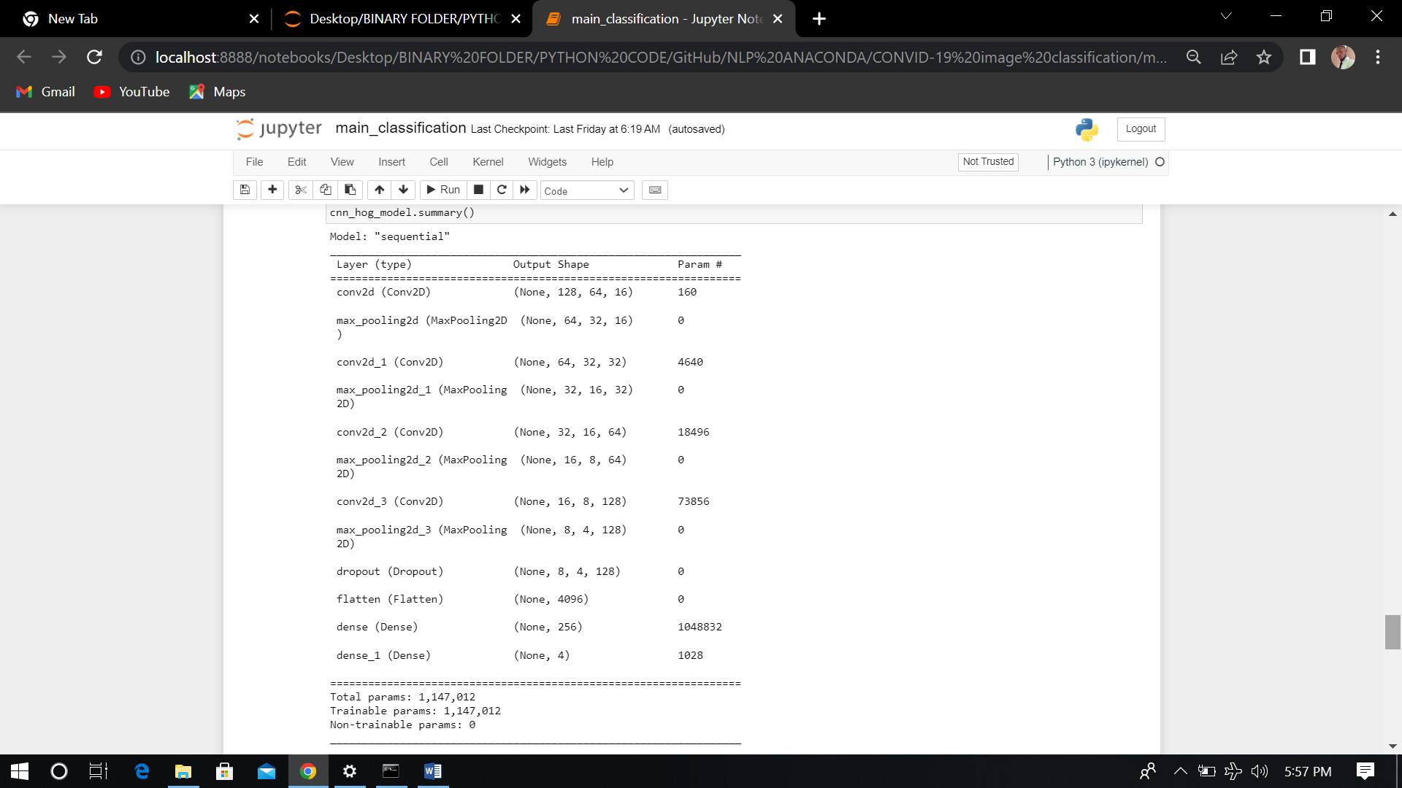**Figure 11 CNN model summary**

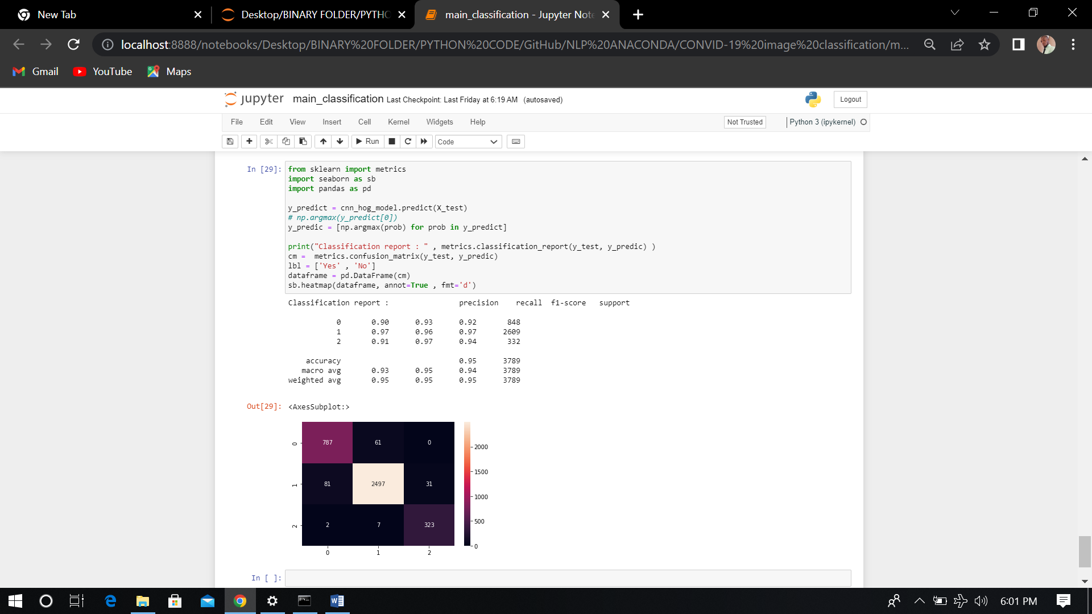

However as indicated in the figure 11 above the layer (type of layer i.e con2d, pooling or dense layer), output shape and the trainable parameter, the summary below show 1,147,012 total available parameter and 1,147,012 trainable parameters along with 0 non-trainable parameter. The Classifier is configured to run or train itself for 16 epoch or iterations. At the 16 iteration an accuracy of 98% percent is achieved, while using ‘*adam’* as optimizer, ‘*sparse* *categorical* *cross* *entropy’* as the loss and ‘*accuracy’* as the metrics.

1. **Model Evaluation**

**Figure 12 CNN Classification Report on the Proposed Model**

Figure 12 above visualize the entire classification reports on each class precision, recall, fi-score and overall accuracy. Based on the above figure, the proposed LBP-HOG-CNN model is 95% percent Accurate. The summary of the above figure 12 is indicated using table 1.

**Table 1 summary for the classification report**

|  |  |  |  |  |
| --- | --- | --- | --- | --- |
| **Index** | **Class** | **Precision** | **Recall** | **Fi-score** |
|  |  |  |  |  |
| 0 | Covid-19 | 90% | 0.93% | 0.92% |
| 1 | Normal | 97% | 96% | 97% |
| 2 | Pneumonia | 91% | 97% | 94% |

**Fig 4.13 Confusion matrix**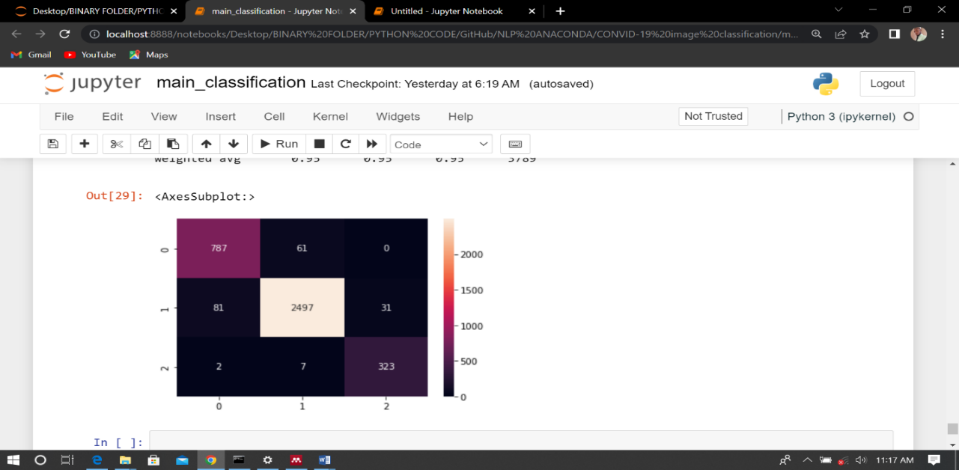

The confusion matrix display what the actual (Y-axis) label or value is in respect to the predicted (X-axis) value. The diagonal value is the corrected predict value. While other value outside the diagonal are the wrongly predicted value. Based on the confusion matrix the class Covid-19 (0) predicted 787 correctly, misclassify 61 value as Normal class and 0 as Pneumonia. Normal class (1) correctly classify 2,497 Normal images correctly and misclassify 81 as covid-19 image, 31 images as Pneumonia. Finally, 323 images for Pneumonia (2) is correctly classify while 2 images are wrongly classified as covid-19 image and 7 as Normal images.

In addition, a comparative analysis between the propose LBP-HOG-CNN model and that of the research work of Chen [2] will be carry out. However, the comparative analysis will be outline using table 2 below.

**Table 2 Permeance measure of existing work and the propose HOG-LBP-CNN model**

|  |  |  |  |  |
| --- | --- | --- | --- | --- |
| **S/N** | **METHODS** | **ACCURACY** | **RECALL** | **PRECISION** |
| **1** | **Statistical Approach** | **82%** | **76%** | **62%** |
| **2** | **CNN** | **85%** | **80.5%** | **69.5%** |
| **3** | **CNN+HOG** | **92%** | **85%** | **91%** |
| **4** | **Proposed LBP-HOG-CNN** | **95%** | **93%** | **92.6%** |

**Chen** [2]

In respect to table 4 its explicitly confirmed that the proposed LBP-HOG-CNN model outperforms the existing model. the application of both LBP and HOG feature extraction improve the CNN classification model in term of accuracy (95%) precision (92%) and recall (93%).

1. **Conclusion**

Based on analysis the hybridization of local binary pattern (LBP) alongside with HOG feature extraction techniques, as shown a great performance in respect to the exiting (Statistical Approach, CNN, and HOG-CNN) [2] techniques. Hence, it can be concluded that the LBP has enhance or improve the prediction and accuracy of the proposed model.

**Reference**

[1] S. Z. Jumani, F. Ali, S. Guriro, I. A. Kandhro, A. Khan, and A. Zaidi, “Facial Expression Recognition with Histogram of Oriented Gradients using CNN,” *Indian J. Sci. Technol.*, vol. 12, no. 24, pp. 1–8, 2019, doi: 10.17485/ijst/2019/v12i24/145093.

[2] J. I. Chen, “Design of Accurate Classification of COVID-19 Disease in X-Ray Images Using Deep Learning Approach,” vol. 03, no. 02, pp. 132–148, 2021.

[3] M. Marufur, R. Sheikh, N. K. M. Azharul, H. Nahin, and K. Dey, “HOG + CNN Net : Diagnosing COVID ‑ 19 and Pneumonia by Deep Neural Network from Chest X ‑ Ray Images,” *SN Comput. Sci.*, vol. 2, no. 5, pp. 1–15, 2021, doi: 10.1007/s42979-021-00762-x.

[4] M. N. T.Seeniselvi, “A Survey on Data Preparation and Feature Engineering in Machine Learning,” *Int. J. Adv. Res. Comput. Eng. Technol.*, vol. 8, no. 5, pp. 191–198, 2019.

[5] J. Li, H. Wei, and W. Hao, “Weight-selected attribute bagging for credit scoring,” *Math. Probl. Eng.*, vol. 2013, 2013, doi: 10.1155/2013/379690.

[6] Y. Kortli, M. Jridi, A. Al Falou, and M. Atri, “Face recognition systems: A survey,” *Sensors (Switzerland)*, vol. 20, no. 2, 2020, doi: 10.3390/s20020342.

[7] P. Goyal, S. Pandey, and K. Jain, *Deep learning for natural language processing: Creating neural networks with Python*. 2018.

[8] I. H. Sarker, “Machine Learning : Algorithms , Real ‑ World Applications and Research Directions,” *SN Comput. Sci.*, vol. 2, no. 3, pp. 1–21, 2021, doi: 10.1007/s42979-021-00592-x.

[9] S. Tang *et al.*, “EDL-COVID: Ensemble Deep Learning for COVID-19 Case Detection from Chest X-Ray Images,” *IEEE Trans. Ind. Informatics*, vol. 17, no. 9, pp. 6539–6549, Sep. 2021, doi: 10.1109/TII.2021.3057683.

[10] O. Lahdenoja, M. Laiho, A. Paasio, E. S-, and S. Nij, “Local Binary Pattern Feature Vector Extraction with CNN,” pp. 202–205, 2005.

[11] A. Abbas, M. M. Abdelsamea, and M. M. Gaber, “Classification of COVID-19 in chest X-ray images using DeTraC deep convolutional neural network,” *Appl. Intell.*, vol. 51, no. 2, pp. 854–864, Feb. 2021, doi: 10.1007/s10489-020-01829-7.

[12] A. M. Ismael and A. Şengür, “Deep learning approaches for COVID-19 detection based on chest X-ray images,” *Expert Syst. Appl.*, vol. 164, Feb. 2021, doi: 10.1016/j.eswa.2020.114054.

[13] A. Rehman, T. Sadad, T. Saba, A. Hussain, and U. Tariq, “Real-Time Diagnosis System of COVID-19 Using X-Ray Images and Deep Learning,” *IT Prof.*, vol. 23, no. 4, pp. 57–62, Jul. 2021, doi: 10.1109/MITP.2020.3042379.

[14] O. Ri, R. Lvhdvh, E. Rq, R. Ri, and W. Hdwxuhv, “,psuryhg &odvvlilfdwlrq ri &rurqdyluxv ‘lvhdvh &29,’ edvhg rq &rpelqdwlrq ri 7h[wxuh )hdwxuhv xvlqj &7 6fdq dqg ; ud\ ,pdjhv,” pp. 105–109, 2021, doi: 10.1109/ICOIACT50329.2020.9332123.

[15] S. Hira, A. Bai, and S. Hira, “An automatic approach based on CNN architecture to detect Covid-19 disease from chest X-ray images,” *Appl. Intell.*, vol. 51, no. 5, pp. 2864–2889, May 2021, doi: 10.1007/s10489-020-02010-w.

[16] Y. Oh, S. Park, and J. C. Ye, “Deep Learning COVID-19 Features on CXR Using Limited Training Data Sets,” *IEEE Trans. Med. Imaging*, vol. 39, no. 8, pp. 2688–2700, Aug. 2020, doi: 10.1109/TMI.2020.2993291.

[17] B. Casper, S. Bojer, and J. P. Meldgaard, “Learnings from Kaggle ’ s Forecasting Competitions,” 2020.

[18] X. Wei, X. Yu, B. Liu, and L. Zhi, “Convolutional neural networks and local binary patterns for hyperspectral image classification,” *Eur. J. Remote Sens.*, vol. 52, no. 1, pp. 448–462, 2019, doi: 10.1080/22797254.2019.1634980.

[19] K. Neighbor *et al.*, “Results in Physics chest X-ray images,” vol. 31, no. November, pp. 0–7, 2021, doi: 10.1016/j.rinp.2021.105045.